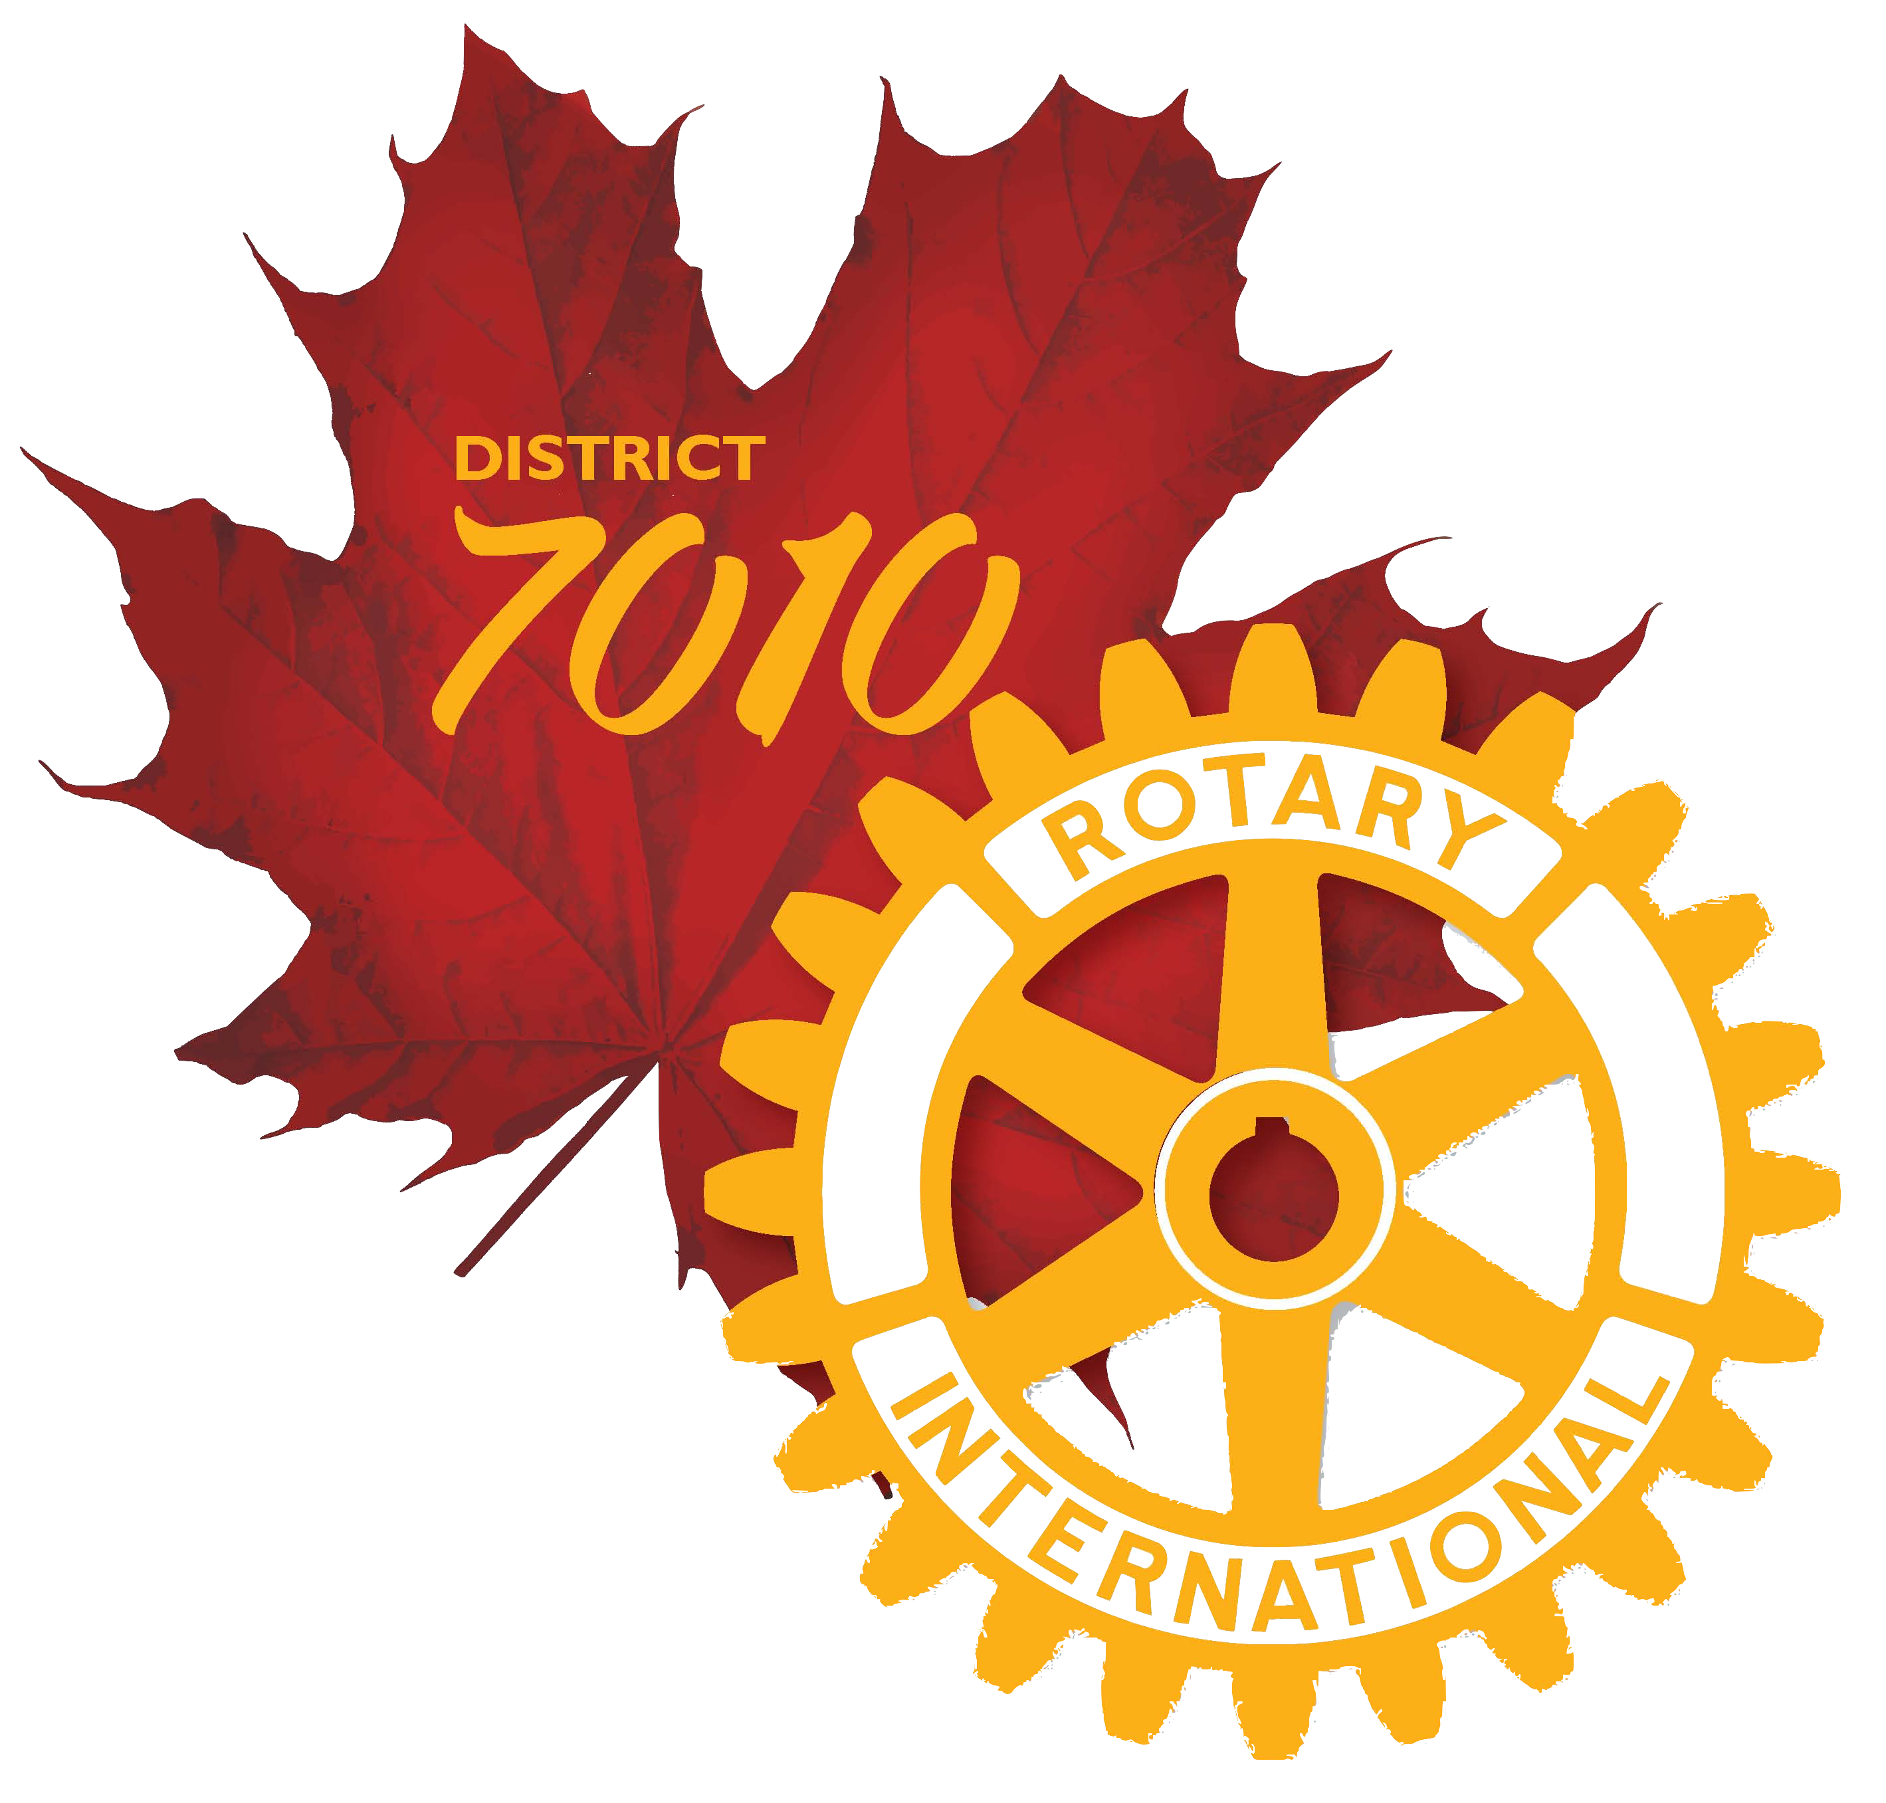
Rotary International District 7010
The Rotary Foundation
Club Memorandum of Understanding

This document is the official Memorandum of Understanding (MOU) provided by The Rotary Foundation (TRF) for clubs. It is an agreement between the club and District 7010, explaining what measures the club will undertake to ensure proper implementation of global and district grant activities and management of Rotary Foundation Global & District Grant funds. By authorizing this document, the club agrees that it will comply with all Foundation requirements.

- Terms of Qualification
- Club Leadership Responsibilities for Qualification
- Financial Management
- Document Retention
- Report on Use of Grant Funds
- Method for Reporting and Resolving Misuse of Grant Funds

1. Terms of Qualification
- Upon successful completion of the qualification requirements, the club will receive qualified status for a period of one year.
- By entering into this agreement and receiving Rotary Foundation grant funds, the club understands and confirms that the club, as an entity, is responsible for the use of grant funds, regardless of which individual(s) or group controlled the funds.
- The club must disclose any potential conflicts of interest and must comply with the Conflict of Interest Policy for Grant Participants as outlined in section 7.030. of the Rotary Foundation Code of Policies.
- The club must cooperate with all District 7010 and TRF audits.

2. Club Leadership Responsibilities for Qualification
- A club member must be appointed to manage club qualification and ensure that stewardship measures and proper grant management practices are implemented for all TRF grants.
- The club must establish a succession plan for the transfer of grant records to ensure retention of information and documentation.
- At least one club member (preferably 2) must complete the grant management and qualification training arranged by the district. The club president-elect should take the training if possible.

3. Financial Management
A. The club must maintain a bank account to be used only for Rotary Foundation Global Grant funds in accordance with applicable laws.
- The account should be low or noninterest-bearing, and any interest earned must be documented and used on eligible, pre-approved grant activities or returned to TRF or to District 7010.
- Grant funds may not be deposited in investment accounts including but not limited to: mutual funds, certificates of deposits, bonds, and stocks.
- Two Rotarian signatories are required on cheques and withdrawals.

B. The club must create a financial management plan that includes measures to:
- Maintain a standard set of accounts, including a complete record of all receipts and disbursements, and maintain receipts for all expenditures equal to or over US$75 or more.
- Disburse grant funds, as appropriate, directly to Rotarians, vendors, and beneficiaries as approved in the grant application. Grant funds not immediately disbursed must be kept in the established project account without diversion, except for direct payment for grant activities or to return funds to the district or TRF.
- Maintain separate statements of income and expenses, noting interest earned and recoveries if applicable.
- Maintain a general ledger that separates funds according to each project.
- Establish an inventory system for the control of equipment and other assets purchased with grant funds, and maintain records for items that are purchased, produced, or distributed through grant activities.
- Perform monthly bank reconciliations.
- Maintain a plan for transferring the custody of the bank accounts in the event of a change in leadership.
- Ensure all grant activities, including the conversion of funds, are in accordance with local law.

4. Document Retention
The club must create a document maintenance system or club archives to maintain original documents for a minimum of five years or longer if required by applicable law, including, but not limited to:
- Documents relating to qualification.
- All records and documentation of policies and procedures required by the club MOU.
- Documentation related to grants, including original documents for all grants, copies of proposals and applications, copies of grant agreements, copies of reports submitted to TRF and the district, receipts and invoices for all purchases made with grant funds, written or electronic correspondence.

Documents must be stored in a known location that is accessible to club Rotarians and must be provided to TRF or to District 7010 upon request or in the case of an audit.
5. Report on Use of Grant Funds
The club must report on the use of grant funds as outlined in the Terms and Conditions for Rotary Foundation District Grants and Global Grants.
6. Method for Reporting and Resolving Misuse of Grant Funds
The club must report any potential misuse or irregularities in grant-related activity to District 7010 - District Governor and District Rotary Foundation Director.
7. Authorization and Agreement
We, being responsible for administering grant activities for the Rotary Club of certify that the club adheres to the requirements listed in this Memorandum of Understanding and will notify
Rotary International District 7010 of any changes or revisions to club policies and procedures related to these requirements.

CLUB PRESIDENT |  |  | CLUB PRESIDENT-ELECT
TERM |  |  | TERM
NAME |  |  | NAME
SIGNATURE |  |  | SIGNATURE
DATE |  |  | DATE

The club members listed below completed the District 7010 Grants Certification Training
NAME |  | E-MAIL
Please forward signed copy to Margaret Walton, District Foundation Director - mwalton7010dg16.17@gmail.com.
It is not necessary to print, sign and scan for sending. The President’s or PE’s submission by email (i.e. e-signatures) will be acceptable.

