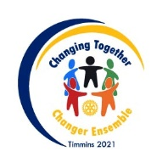
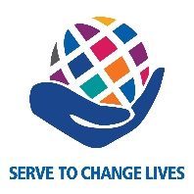
District Governor
Club Achievement Recognition
2021-2022

To achieve the Club Recognition for 2021-2022, clubs must complete the following goals by June 30, 2022.

- Club membership growth at June 30, 2022. Minimum net increase from membership at July 1, 2021 of (clubs under 39, net+1), (clubs 40-99, net +2), (clubs over 100, net + 3).

- Total contribution to The Rotary Foundation Annual Fund by your club and your members should exceed $125 per member.

- Total contributions to the PolioPlus Fund by your club and your members should exceed $50 per member.

- Keep your club website and social media sites up to date by displaying the most current information and contact info, meeting info, descriptions of projects complete with pictures.

- Have at least two of your members attend the District Conference.

- Have at least four of your club members participate in Rotary Learning Institute or Rotary Weekend.

- Hold at least one club Strategic Planning session or review meeting. Consider utilizing the help of the District Club Strategic Planning committee.

- Have these goals entered in Rotary Club Central (RCC).
Please submit the completed form to your Area’s Assistant Governor prior to June 30, 2022.

Item | Goal | Actual/Completed
- Membership
- Annual Fund
- PolioPlus
- Social Media | Up to date and informative
- District Conference
- RLI/Rotary Weekend
- Strategic Plan | Club Strategic Planning Session
- Goals in RCC | Input

Rotary Club of __________________________________________________________________

Date: ____________________________________________________

